## Declaration

I, [Student Name], declare that this assignment, titled [Assignment Title], is my own original work and has not been copied from any other source except where explicitly acknowledged. I have not engaged in plagiarism, collusion, or any other form of academic misconduct in the preparation and submission of this assignment. All sources of information and data used in this assignment have been properly cited and referenced in accordance with the prescribed guidelines. I have not used unauthorized assistance in the preparation of this assignment and have not allowed any other student to copy my work. I am aware that any breach of academic integrity may result in disciplinary action as per the [policies of Monash University](https://www.monash.edu/learning-teaching/priorities-and-programs/assessment-and-academic-integrity/assessments-and-integrity-policy-and-procedure), which may include failing this assignment or the course, and further academic penalties.

Signature: ________________________ Date: _____________________________

## Github Check

Enter your Github details here.

|  |  |
| --- | --- |
| Github Username  *Enter your username here* | <username> |
| **A3 GitHub repository**  *Have you started and shared your assignment repository with your tutor yet?* | No |

## Self-Evaluation

Rate your performance for each criteria. Put a ✅(tick) in the box where you think your work belongs.

|  |  |  |  |  |
| --- | --- | --- | --- | --- |
| **Criteria** | **Exceeds Expectations** | **Meets Expectations** | **Needs Improvement** | **Fail to meet expectations** |
| Executive Summary | ✅ |  |  |  |
| User Personas | ✅ |  |  |  |
| Sitemap | ✅ |  |  |  |
| Wireframes/Low-fidelity Prototype | ✅ |  |  |  |

## 

## Section 1: Executive Summary

The Asylum Seeker Refugee Centre (ASRC) is Australia’s largest independent, non-profit organisation dedicated to supporting those seeking asylum. ASRC provides essential resources such as food, shelter, healthcare, and general supplies. They also offering legal aid, community support, and educational services. As part of their mission to uphold and enhance the physical, mental, and social wellbeing of asylum seekers / refugees, ASRC aims expand its digital presence and develop a modern web application to improve accessibility to required services.

By offering an online platform, ASRC will be better position to provide faster and more accessible aid, enabling more accurate tailoring of support services to individual needs. This web application is designed to serve both asylum seekers and refugees. The digital transformation will enhance this organisation’s ability to assess asylum seekers’ requirements, connect them with the right resources, and assist them in their journey to obtaining refugee status. Additionally, the platform will further assist refugees in adapting to their new environment by offering information and community driven support to ease their transition. The web application will act as a centralised platform to streamline support services, ensuring that both asylum seekers and refugees can access crucial assistance efficiently.

The development of this web application is guided by three core principles (user centric design, clear navigation, and intuitive usability). To ensure an optimal user experience, the website will be segregated into four distinct sections which are aligned to ASRC’s core operating objectives. The first is the landing page which utilises minimalist design principles to provide a high-level introduction to ASRC, its mission, services, and available resources. Next is the community section aimed to foster engagement through discussion forums and social integration initiatives. This creates a space for users to connect and share experiences. The publications pages will offer access to reports, legal guidelines, and informative articles, equipping users with the knowledge to understand their rights and options. Finally, the resources pages will serve as a comprehensive directory of services, featuring interactions with industry professionals for support and employment related tools.

In addition to the core sections, the platform will also feature dedicated areas for user login / registration, donations, and ASRC contact information. These sections are aimed to further augment access, support, and community engagement.

By implementing a structured and intuitive web platform, ASRC aims to increase its capacity to support asylum seekers and refugees, fostering a more inclusive and accessible pathway toward stability and integration.

## Section 2: User Personas

Persona 1: Farida Khan

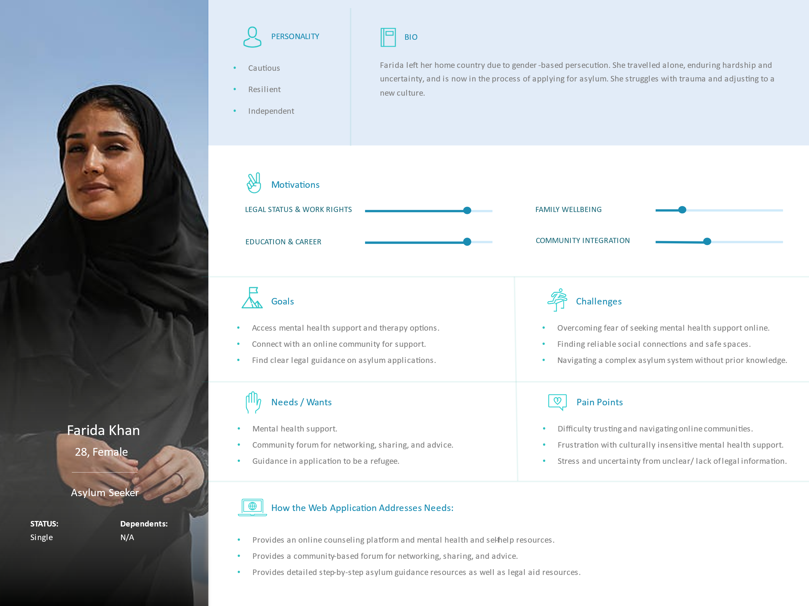

Persona 2: Omar Dabo

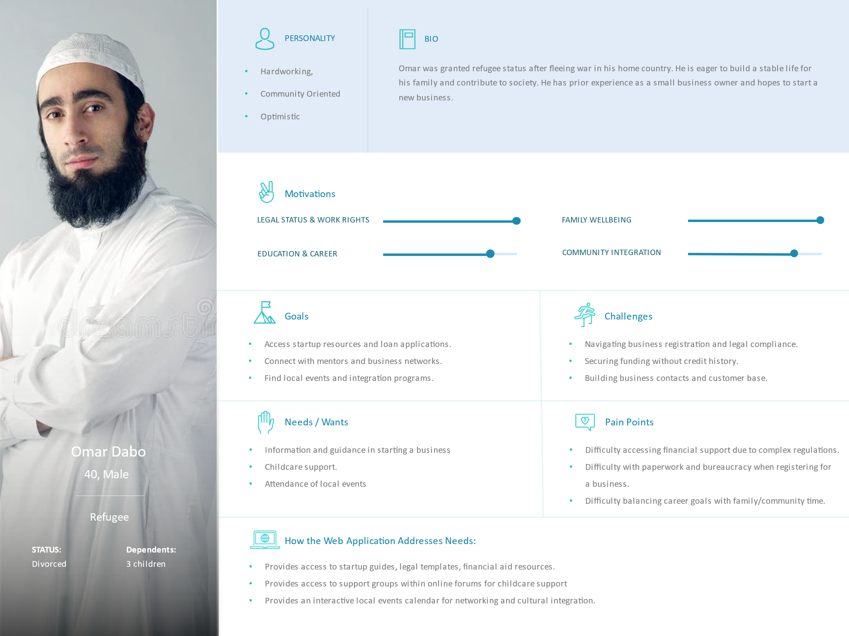

Persona 3: Amina Yusuf

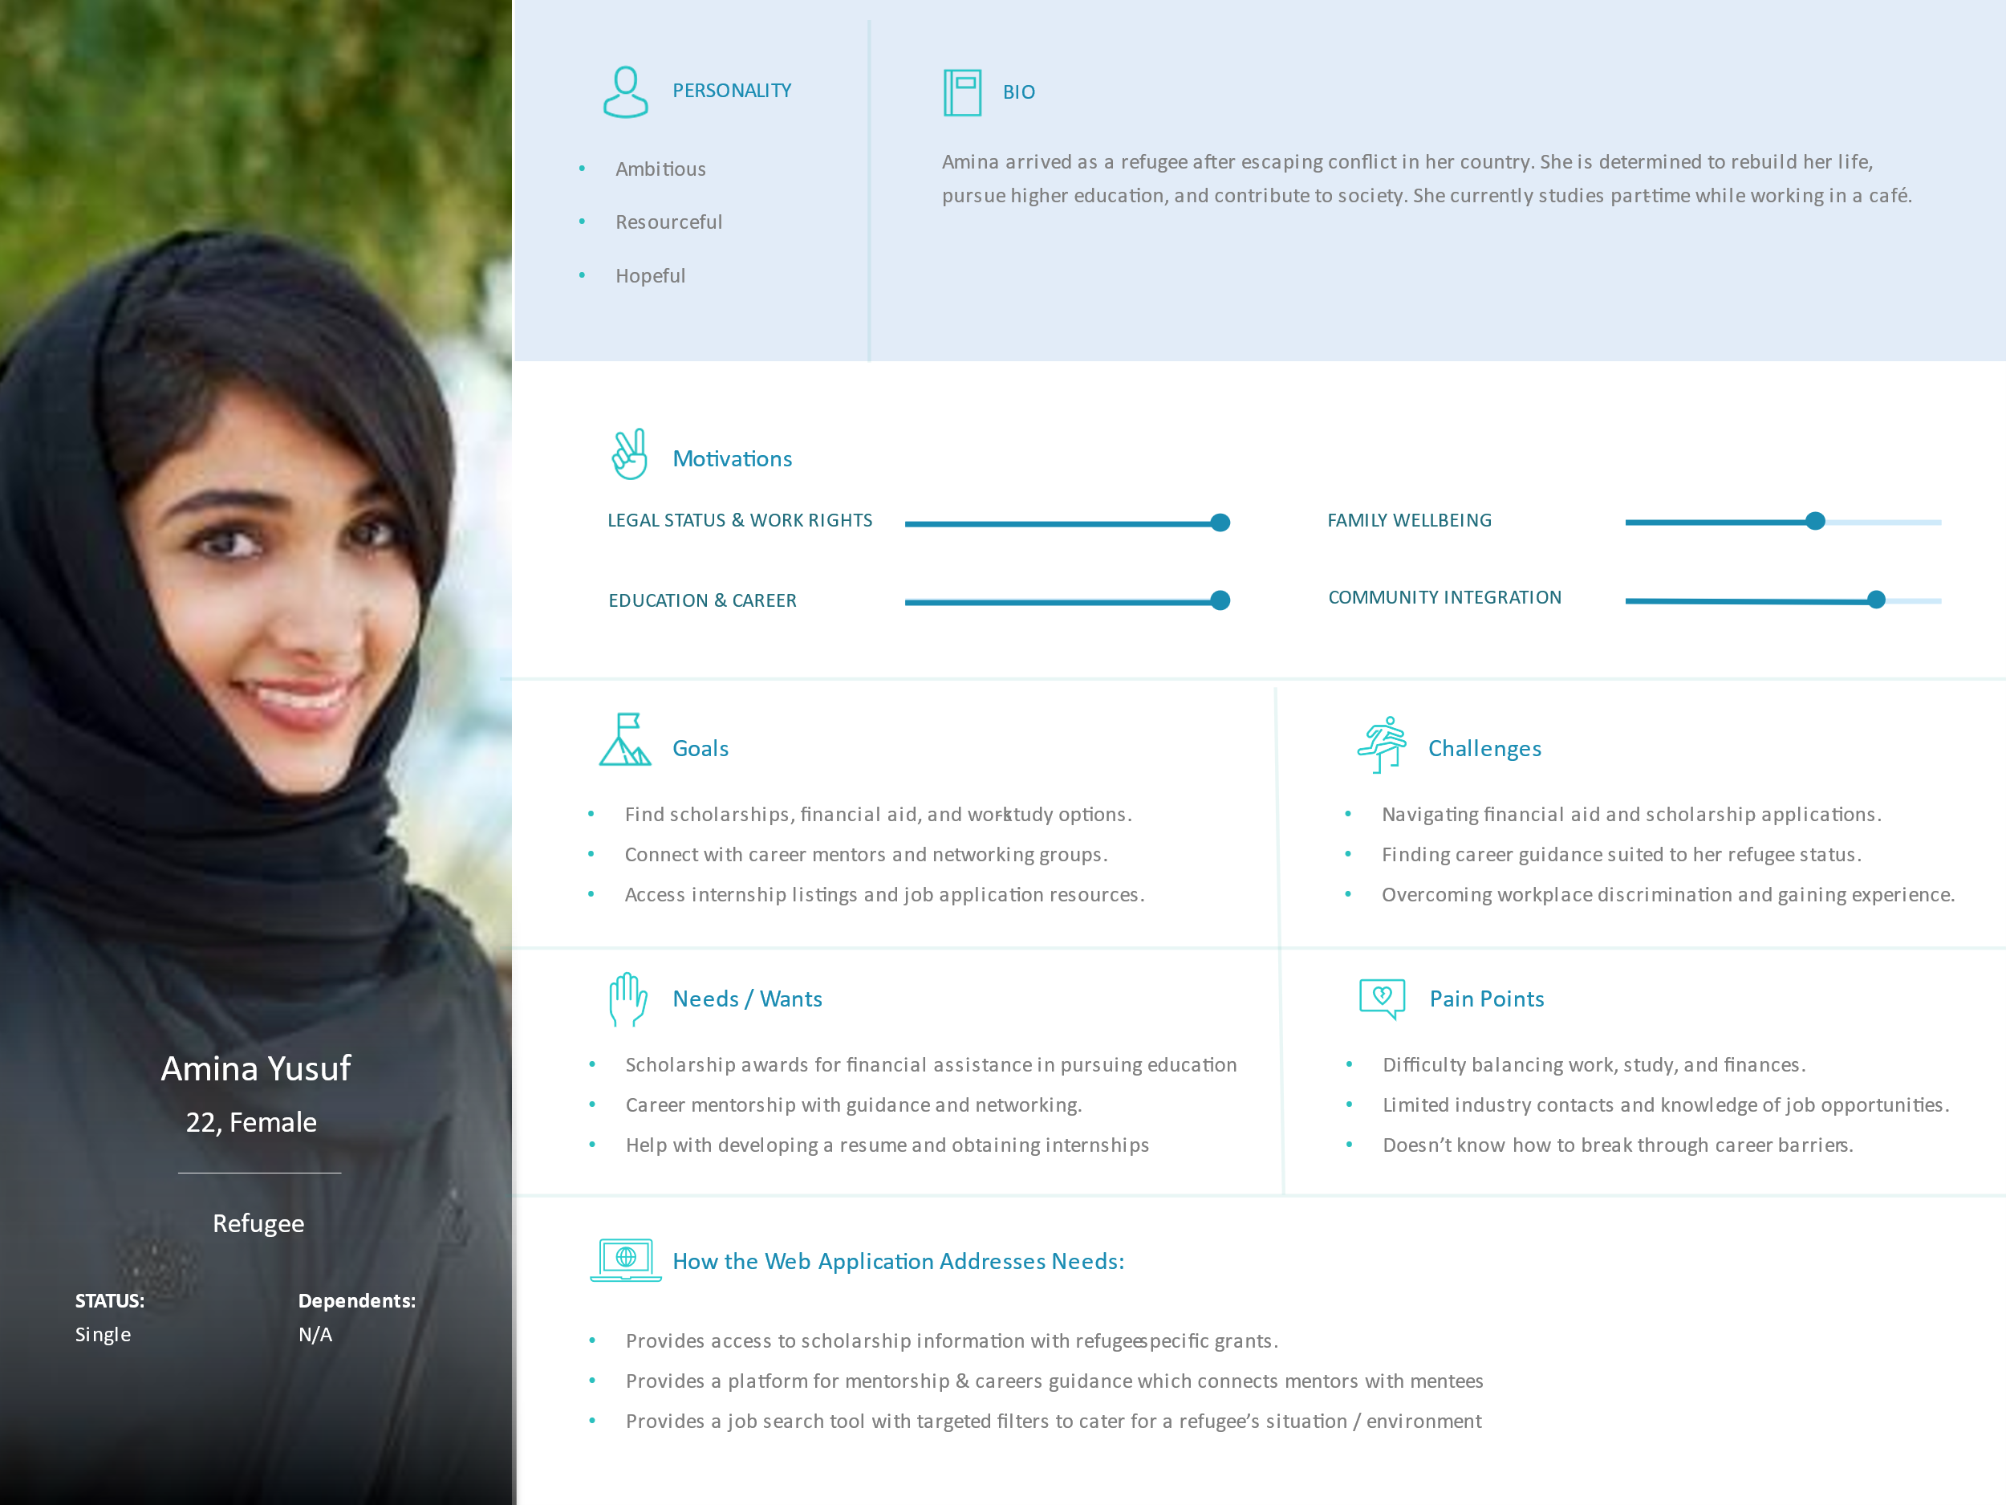

## Section 3: Sitemap

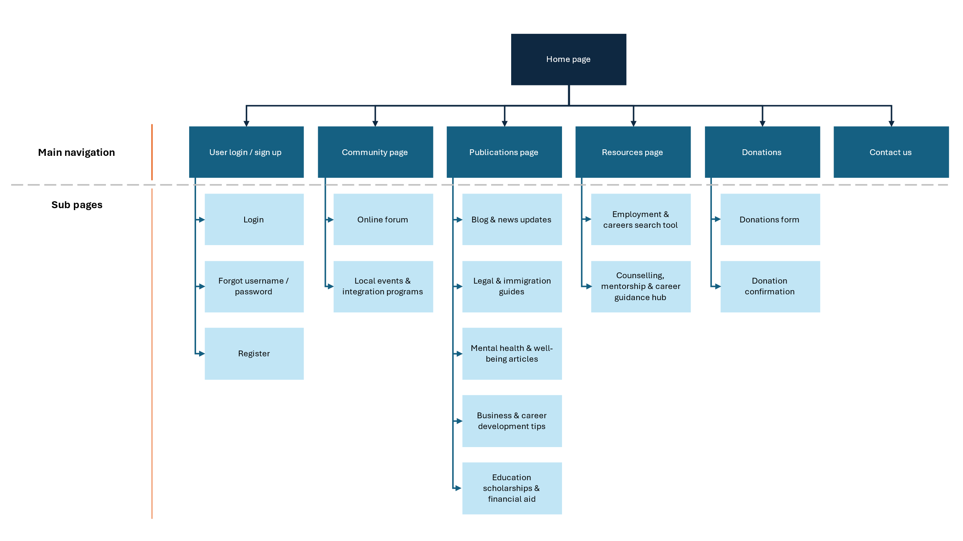

1. User login / sign up: enable login for access to forums and hubs
2. Community page: provides a communication channel to the asylum seeker / refugee communities
3. Publications page: provides relevant and updated information on common topics of interest
4. Resources page: provides the tooling to search for employment and obtain guidance from chosen personnel
5. Donations: enable users to make donations
6. Contact us: provides a central point of contact for further inquiries and support

## Section 4: Wireframes/Low-fidelity prototype

## Declaration: Additional Help

Any tools that you used (including Gen AI or existing code reuse) must be declared here.

**Note**: GenAI is not allowed for coding purposes in any assignment,

However, you may use GenAI for brainstorming and problem solving. You need to declare all such uses here. One row per help used.

|  |  |
| --- | --- |
| Name | Description |
| *Example: ChatGPT for brainstorming ideas* | *I used ChatGPT to brainstorm how to do X because I was feeling stuck with Y problem.* |
|  |  |